**Experiment 12 - Puppet**

| Roll No. | 37 |
| --- | --- |
| Name | Mikil Lalwani |
| Class | D15-B |
| Subject | DevOps Lab |
| LO Mapped | LO1: To understand the fundamentals of DevOps engineering and be fully proficient with DevOps terminologies, concepts, benefits, and deployment options to meet your business requirements.  LO6: To Synthesize software configuration and provisioning using Ansible/Puppet. |
|

**Aim**:

To install and Configure Pull based Software Configuration Management and provisioning tools using Puppet.

**Introduction**:

What is Puppet?

Puppet is an open-source Software Configuration Management and Deployment tool. It's mostly used in Linux Cloud environments to automate infrastructure, management of different servers, etc.

Puppet Architecture

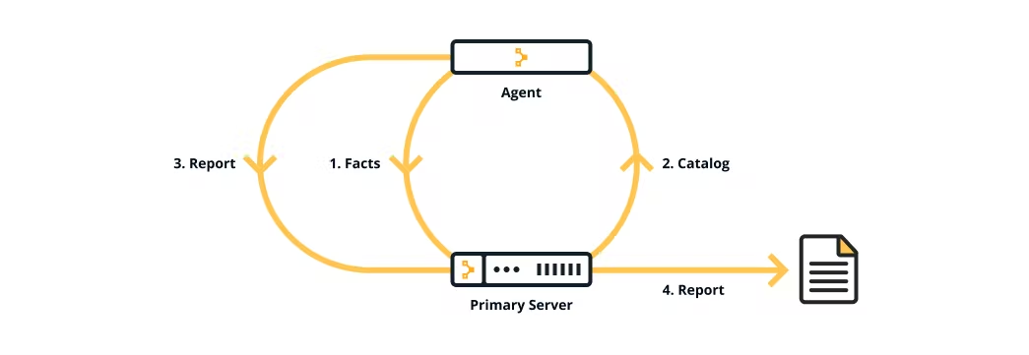

Puppet uses a Master-Agent architecture in which the Master and Slave communicate through a secure encrypted channel with the help of SSL.

Puppet Master

Puppet Master is the Hub or the main node in the network of systems that handles all the configuration across systems. It is capable of applying different configurations to other nodes called Puppet Agents.

Puppet Agent

Puppet Agents are working machines in which different servers are set up for different use cases. These servers and their configurations are managed by the Puppet Master.

Use Cases

Server and Database Management

Multiple Servers and Databases can be controlled in one place using Puppet.

System Configuration

A key feature of Puppet is that multiple systems can be configured at once from the Puppet Master device.

Networking

Due to Puppet's architecture, it can be used for secure networking and data transfer across systems.

Container Management

Puppet makes it easy to integrate containers with existing IT infrastructure.

1. Create two EC2 Ubuntu instances and security group.

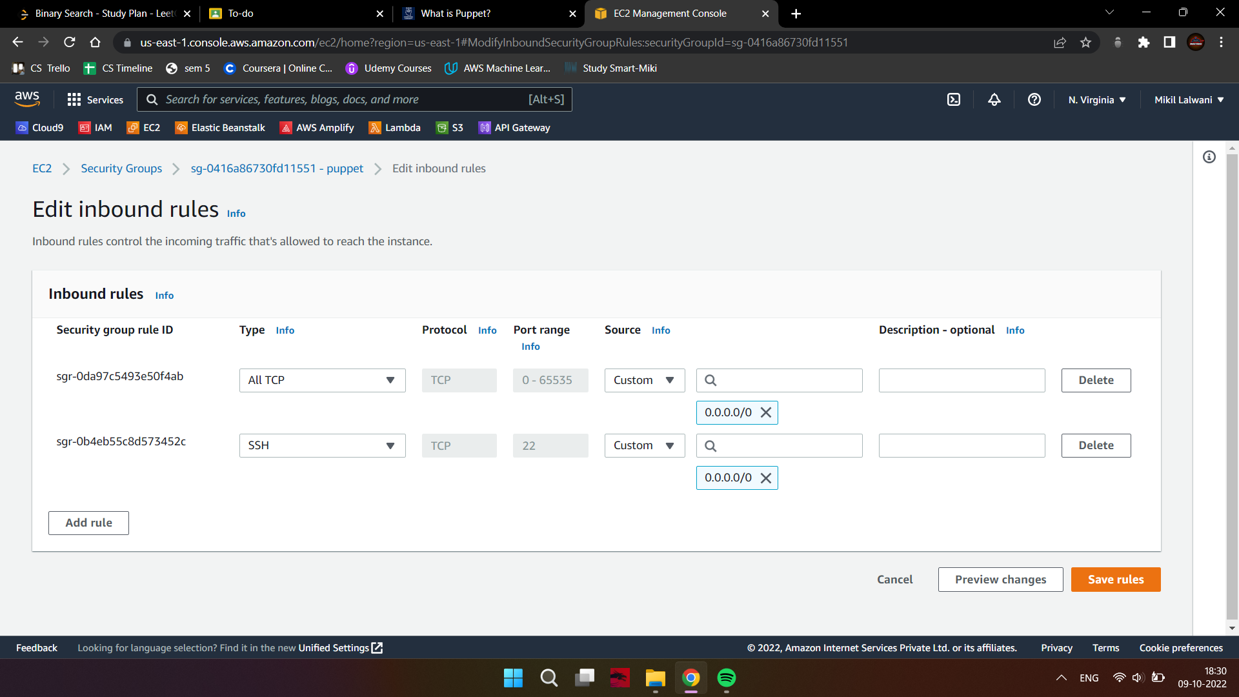

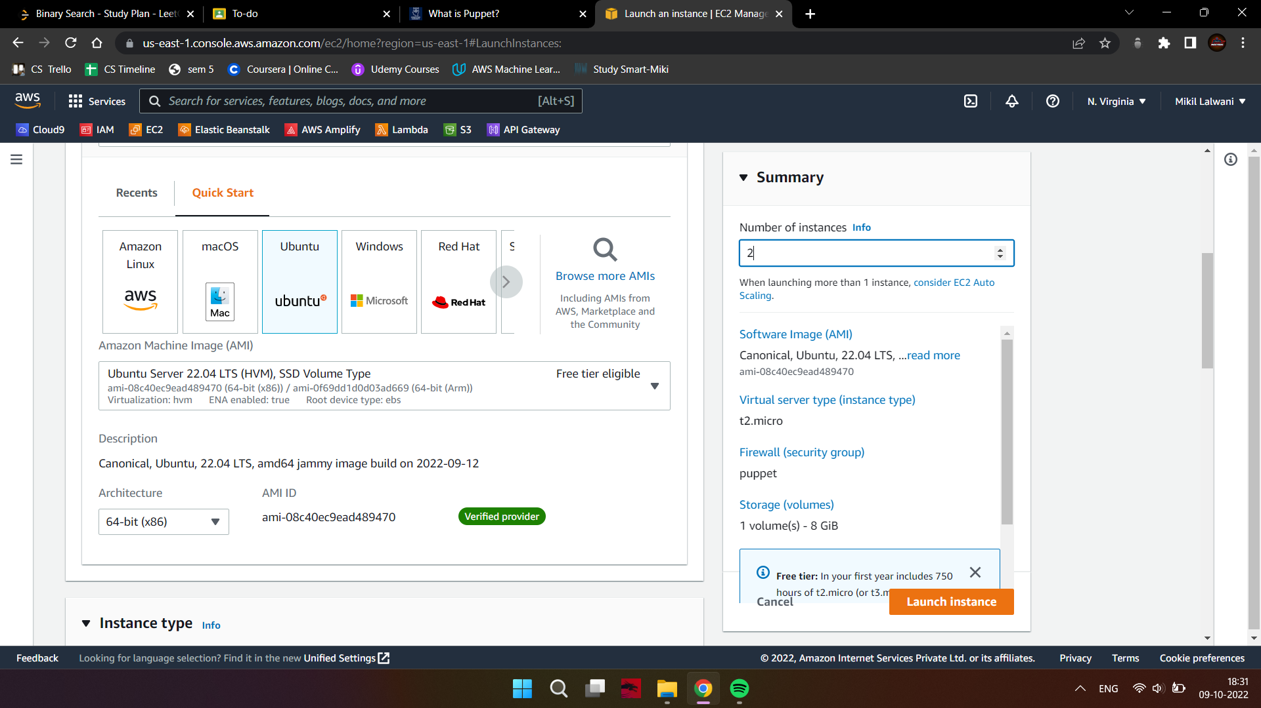

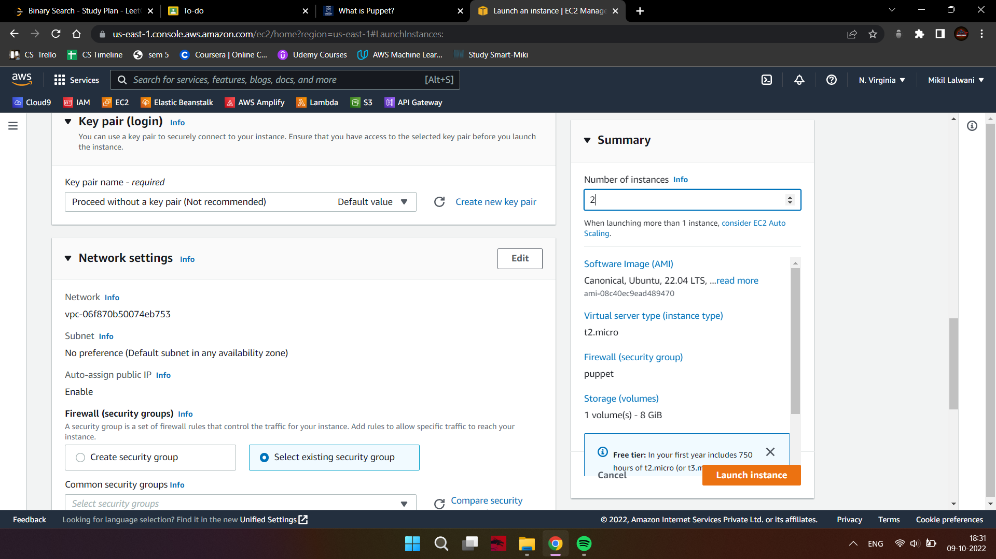

1. Name them Server and Agent.

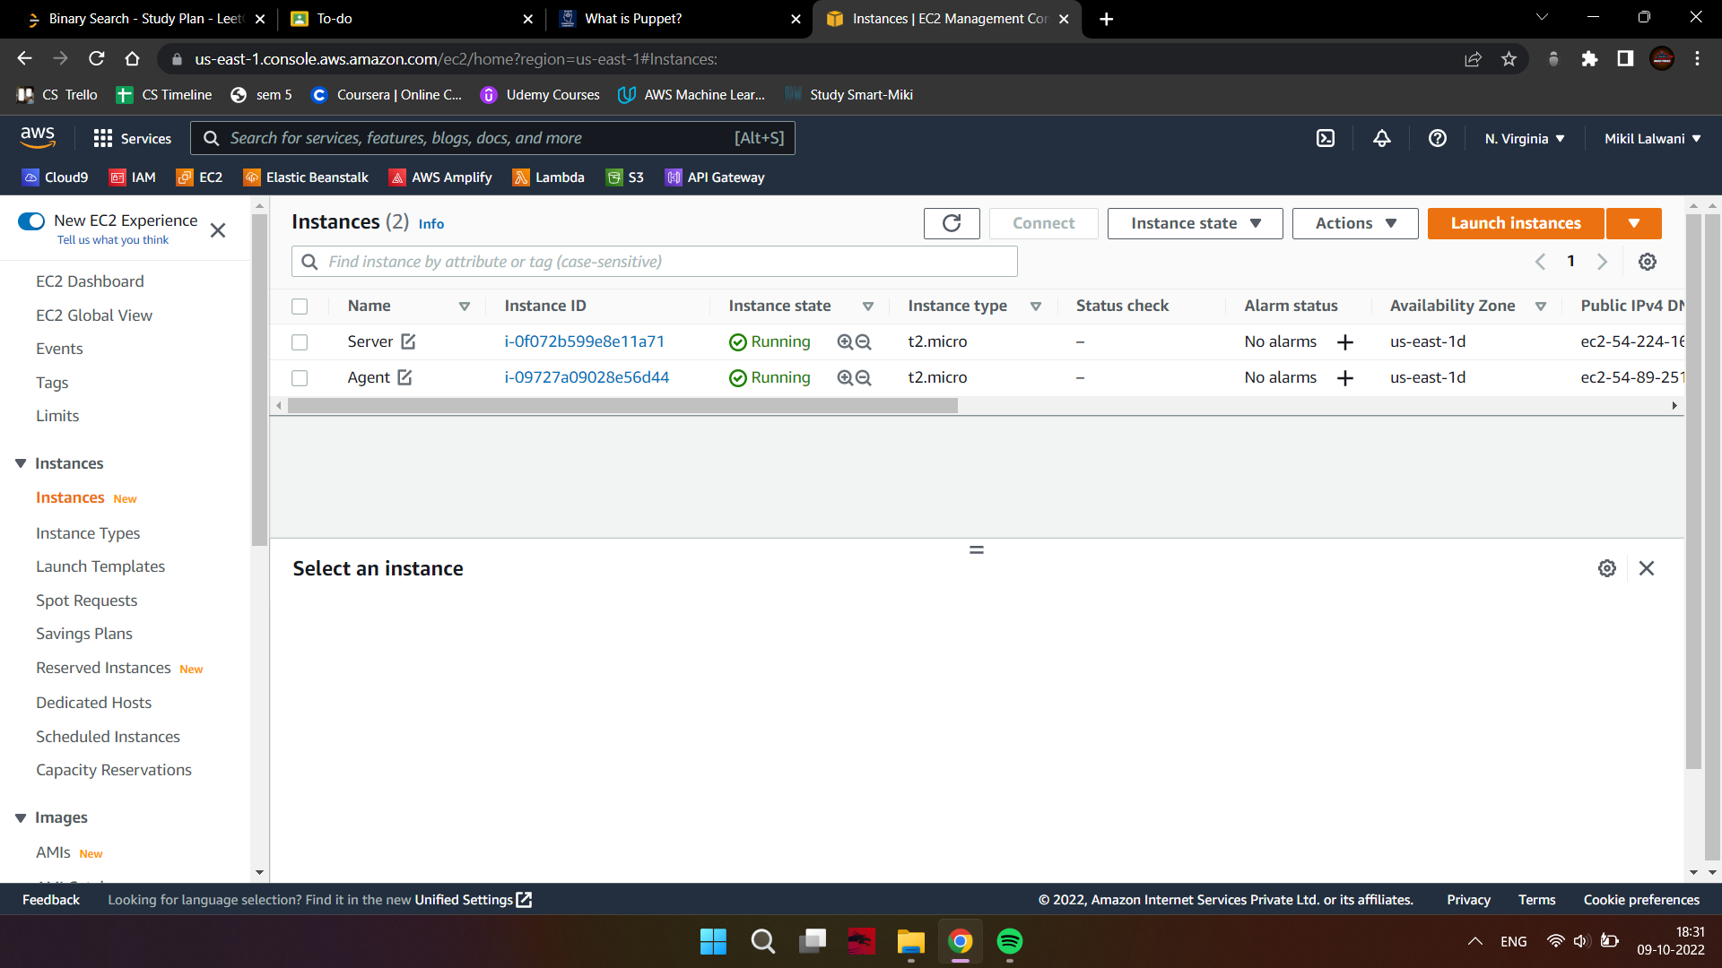

Follow instructions only on the mentioned machine(s)

1. On both master and client, Update Package List.

sudo apt-get update -y

1. On both master and client, set up the hostname resolution.

sudo nano /etc/hosts

Now, paste the following lines at the end of each file. These IP addresses are the Public

IPv4 addresses of your instances. puppetmaster is your server and puppetclient is the

client.

[puppet master ip] puppetmaster puppet

[puppet client ip] puppetclient

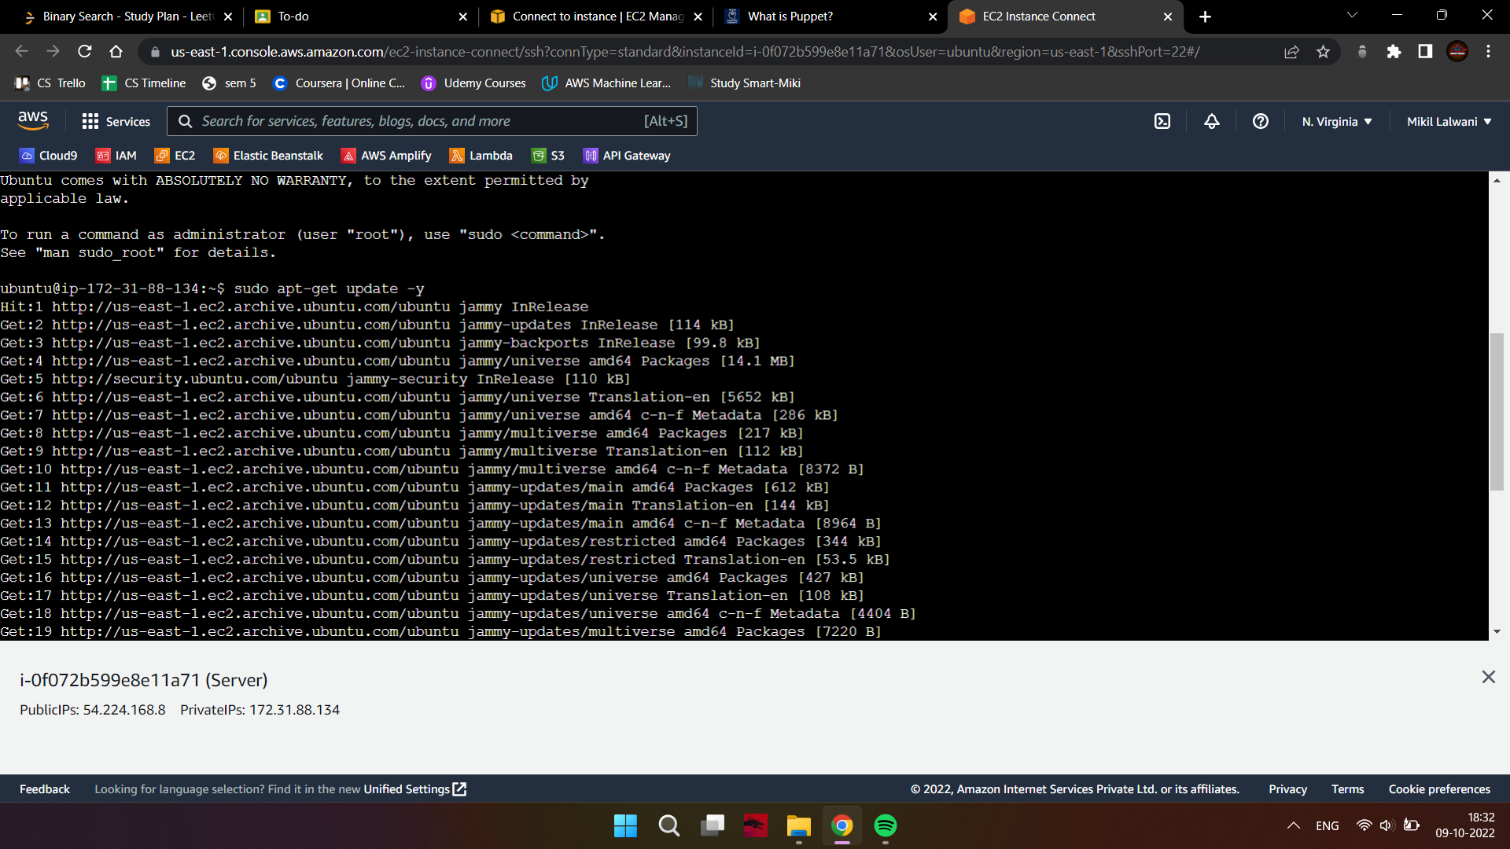

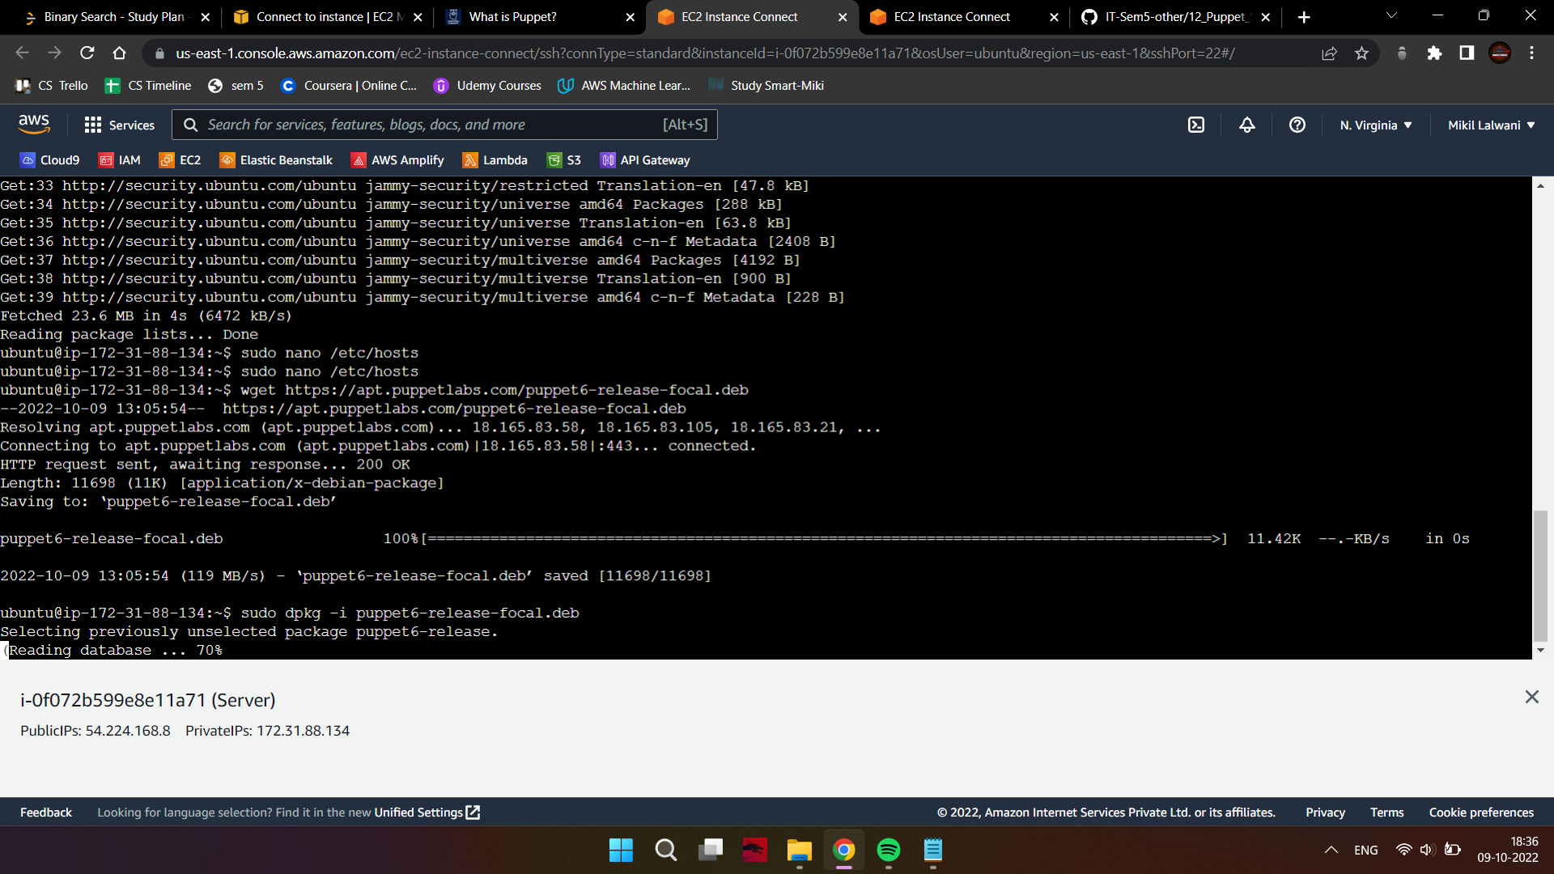

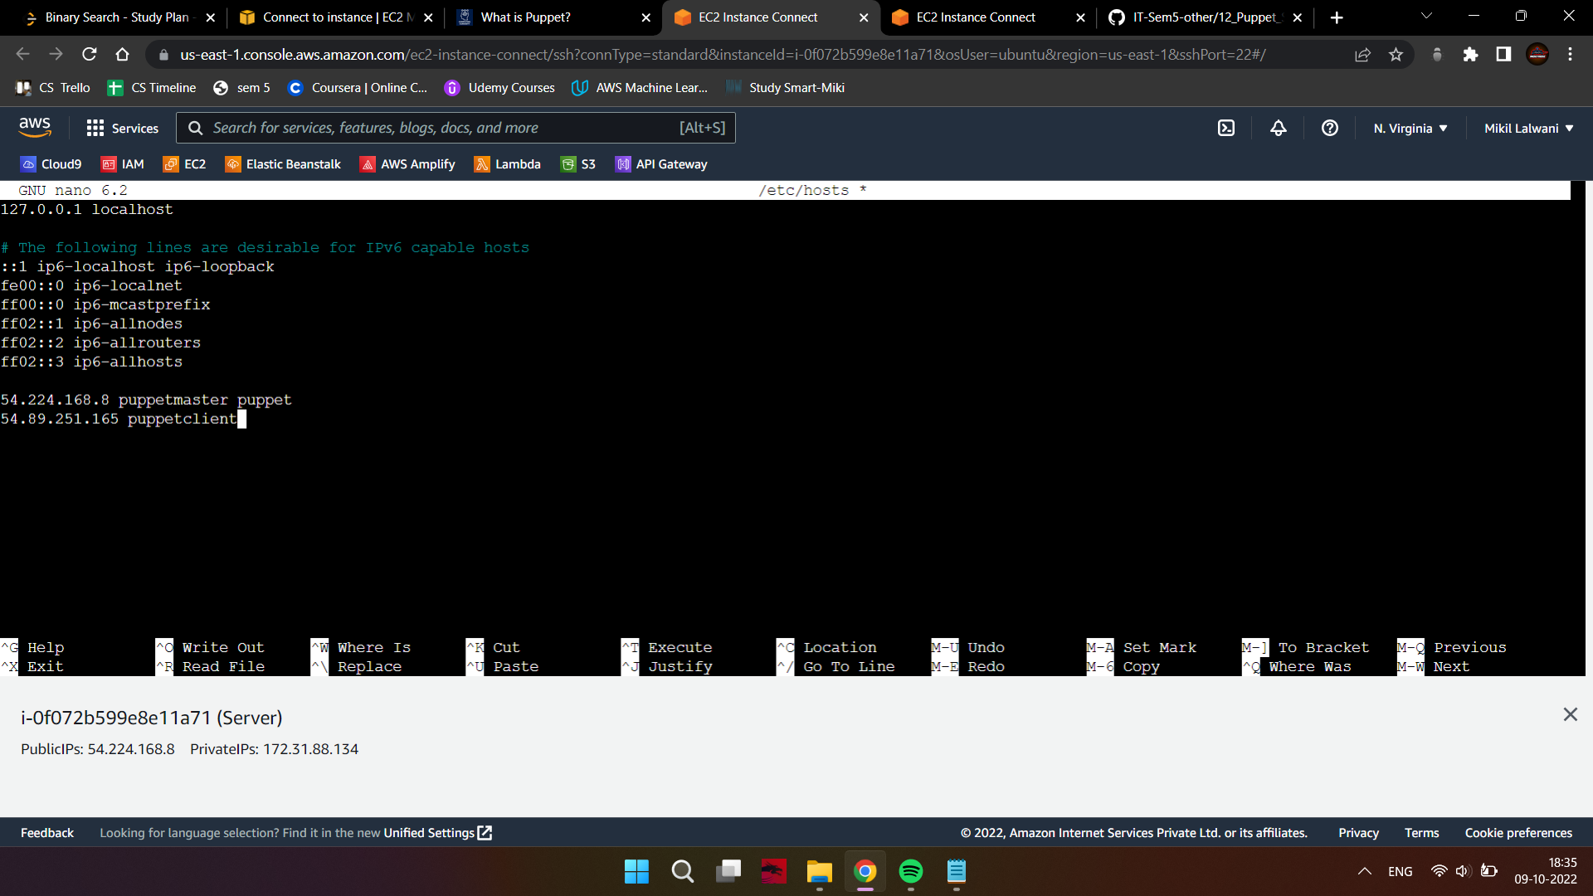

Follow these instructions only on the master machine.

1. Download the latest Puppet Version

wget <https://apt.puppetlabs.com/puppet6-release-focal.deb>



1. Once the download is complete, install the package by using dpkg

sudo dpkg -i puppet6-release-focal.deb



1. Update the package repository:

sudo apt-get update -y

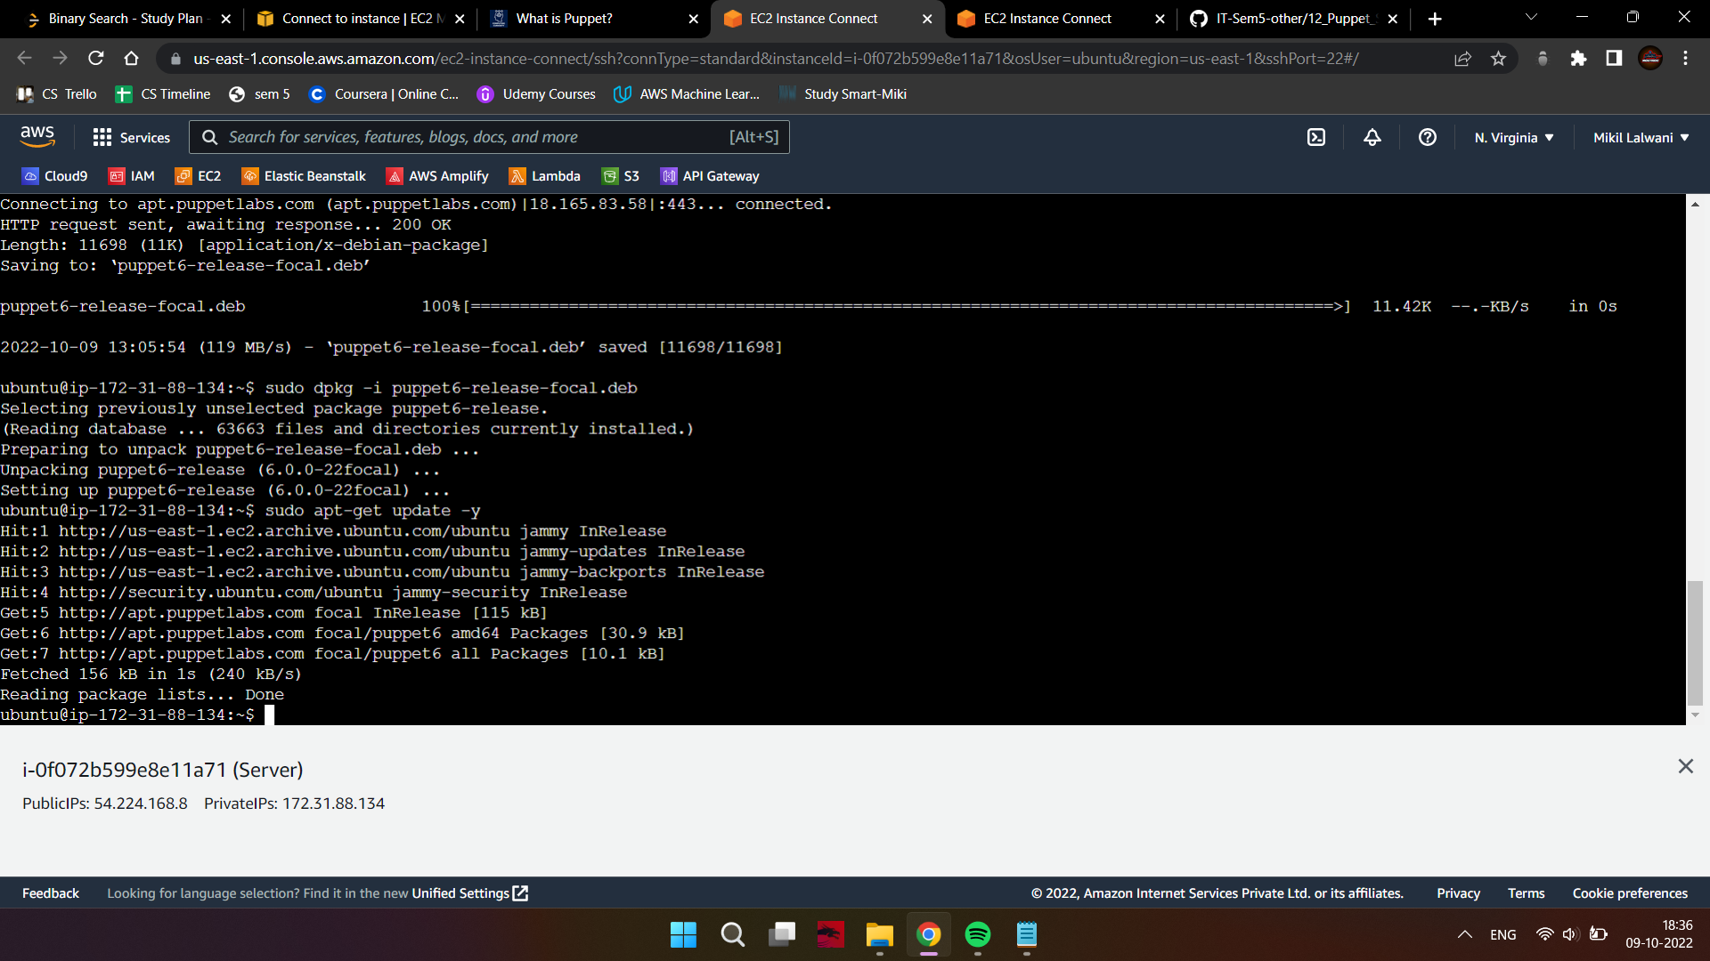

1. Install the puppet server.

sudo apt-get install puppetserver -y

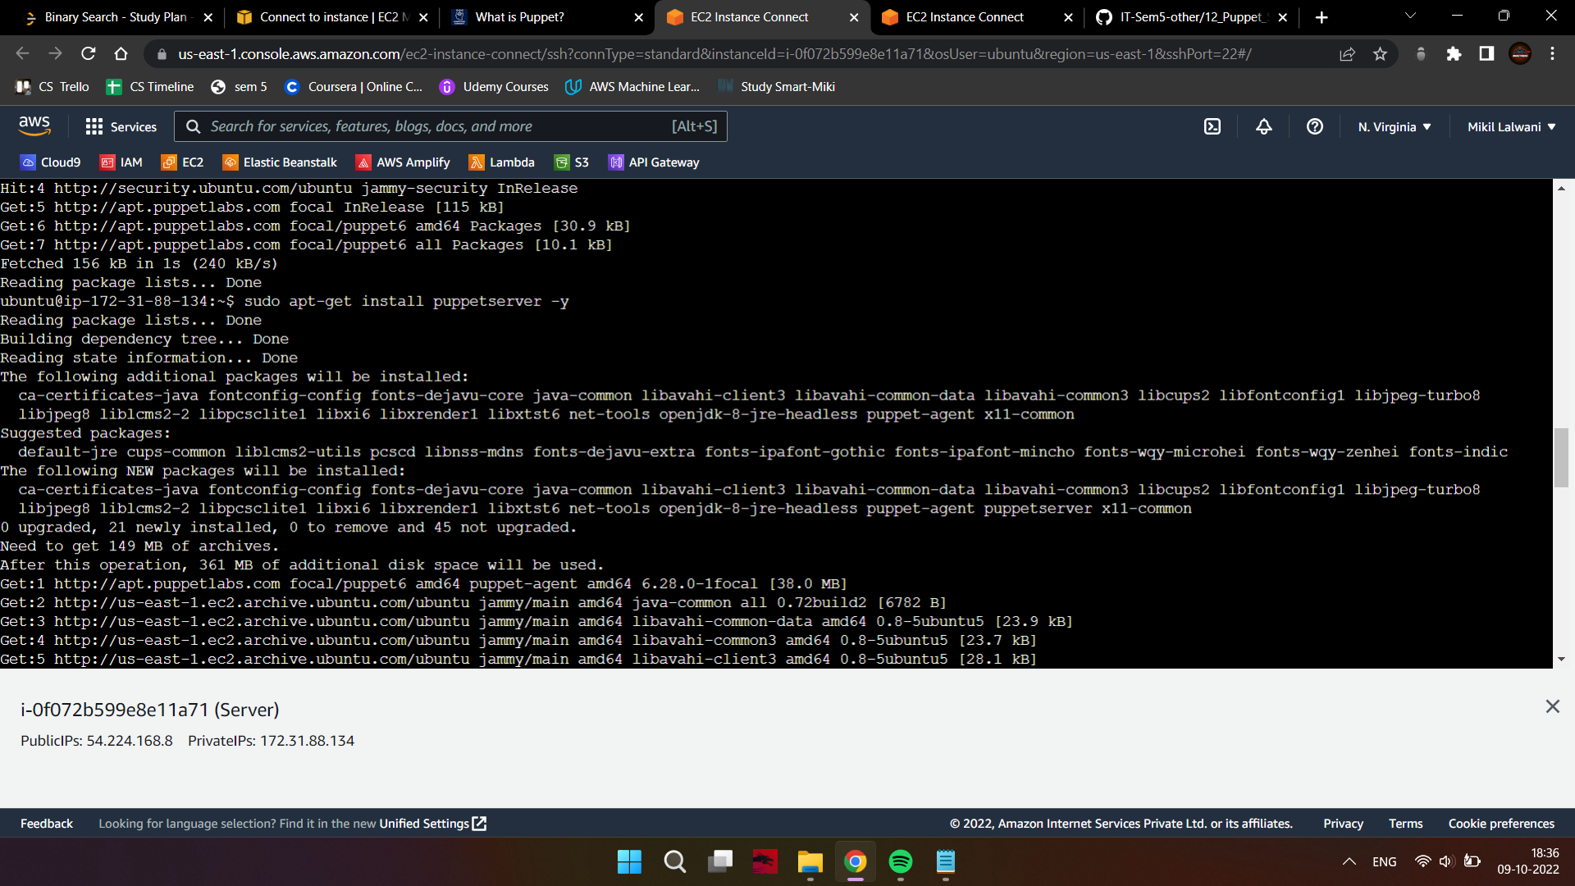

Configuration:

1. Open the puppetserver file, under which you need to change the memory size from 2GB

to 300MB since we don’t want it to overload our instance which has only 1 GB of RAM.

sudo nano /etc/default/puppetserver

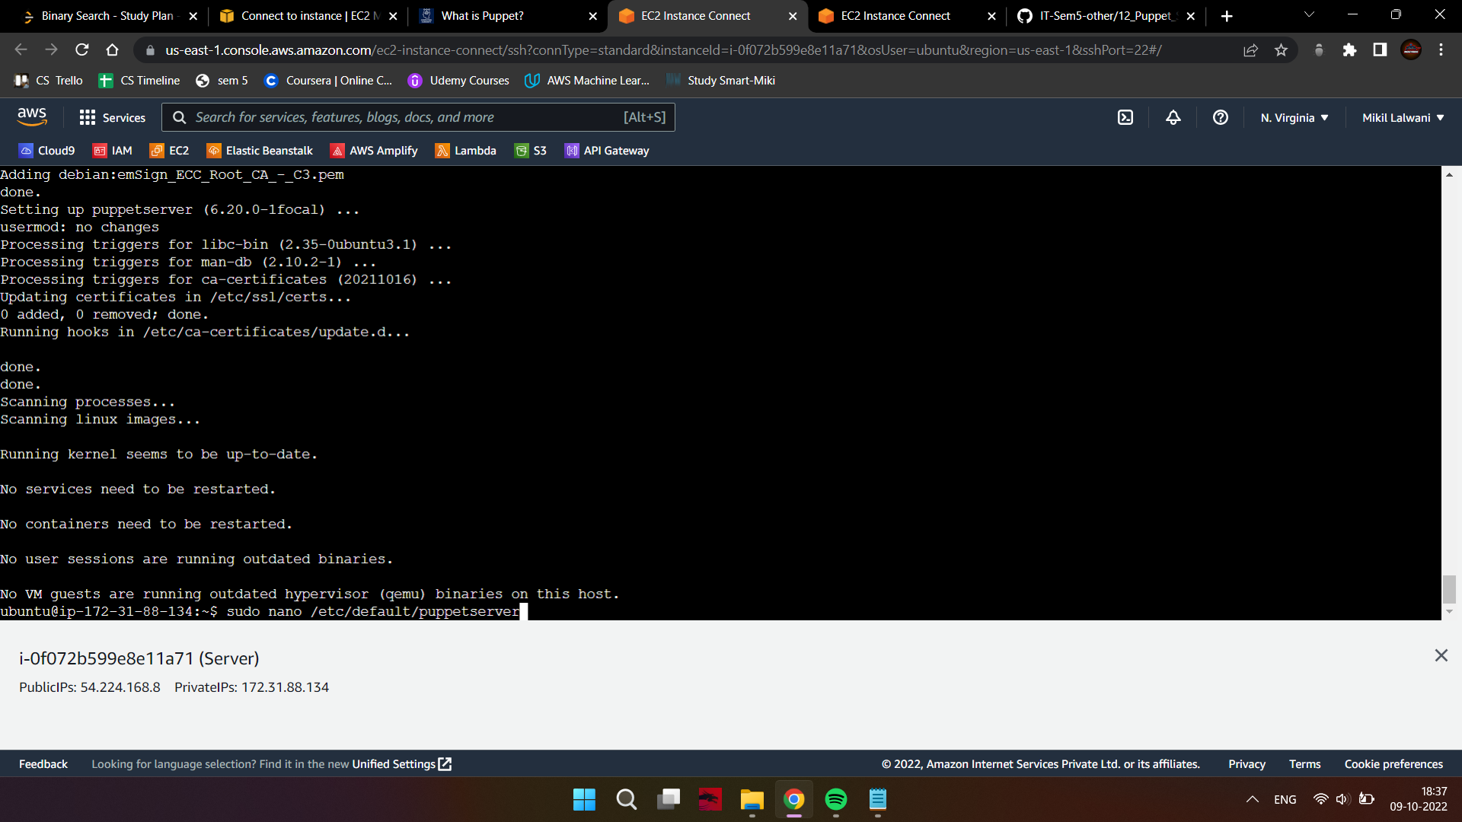

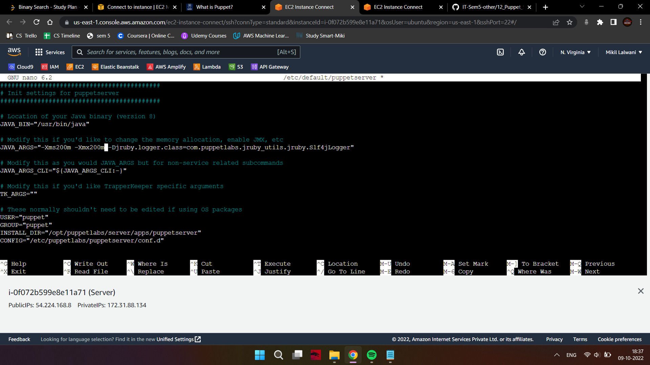

1. Start and enable the Puppet Service

sudo systemctl restart puppetserver

sudo systemctl enable puppetserver

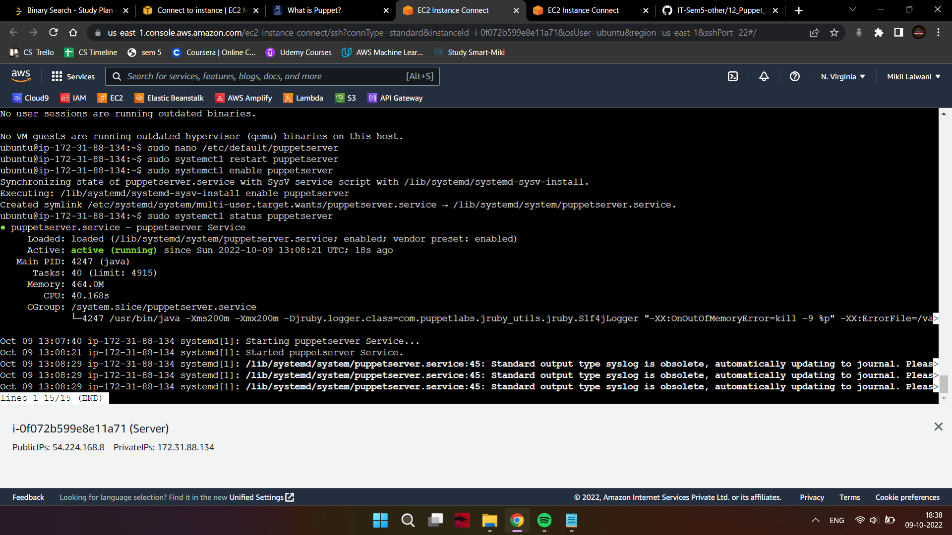

1. Verify the status of the service.

sudo systemctl status puppetserver



Now that our server is up and running, let’s move to the client machine.

Perform these commands only on the client machine.

1. Download the latest version of Puppet on the client.

wget <https://apt.puppetlabs.com/puppet6-release-focal.deb>

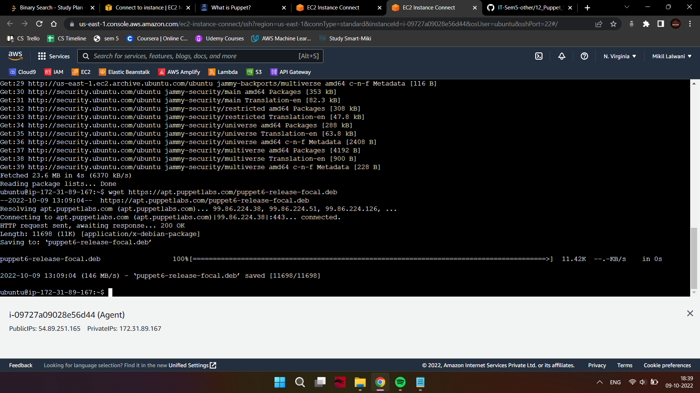

1. Once the download is complete, use dpkg to install the package.

sudo dpkg -i puppet6-release-focal.deb

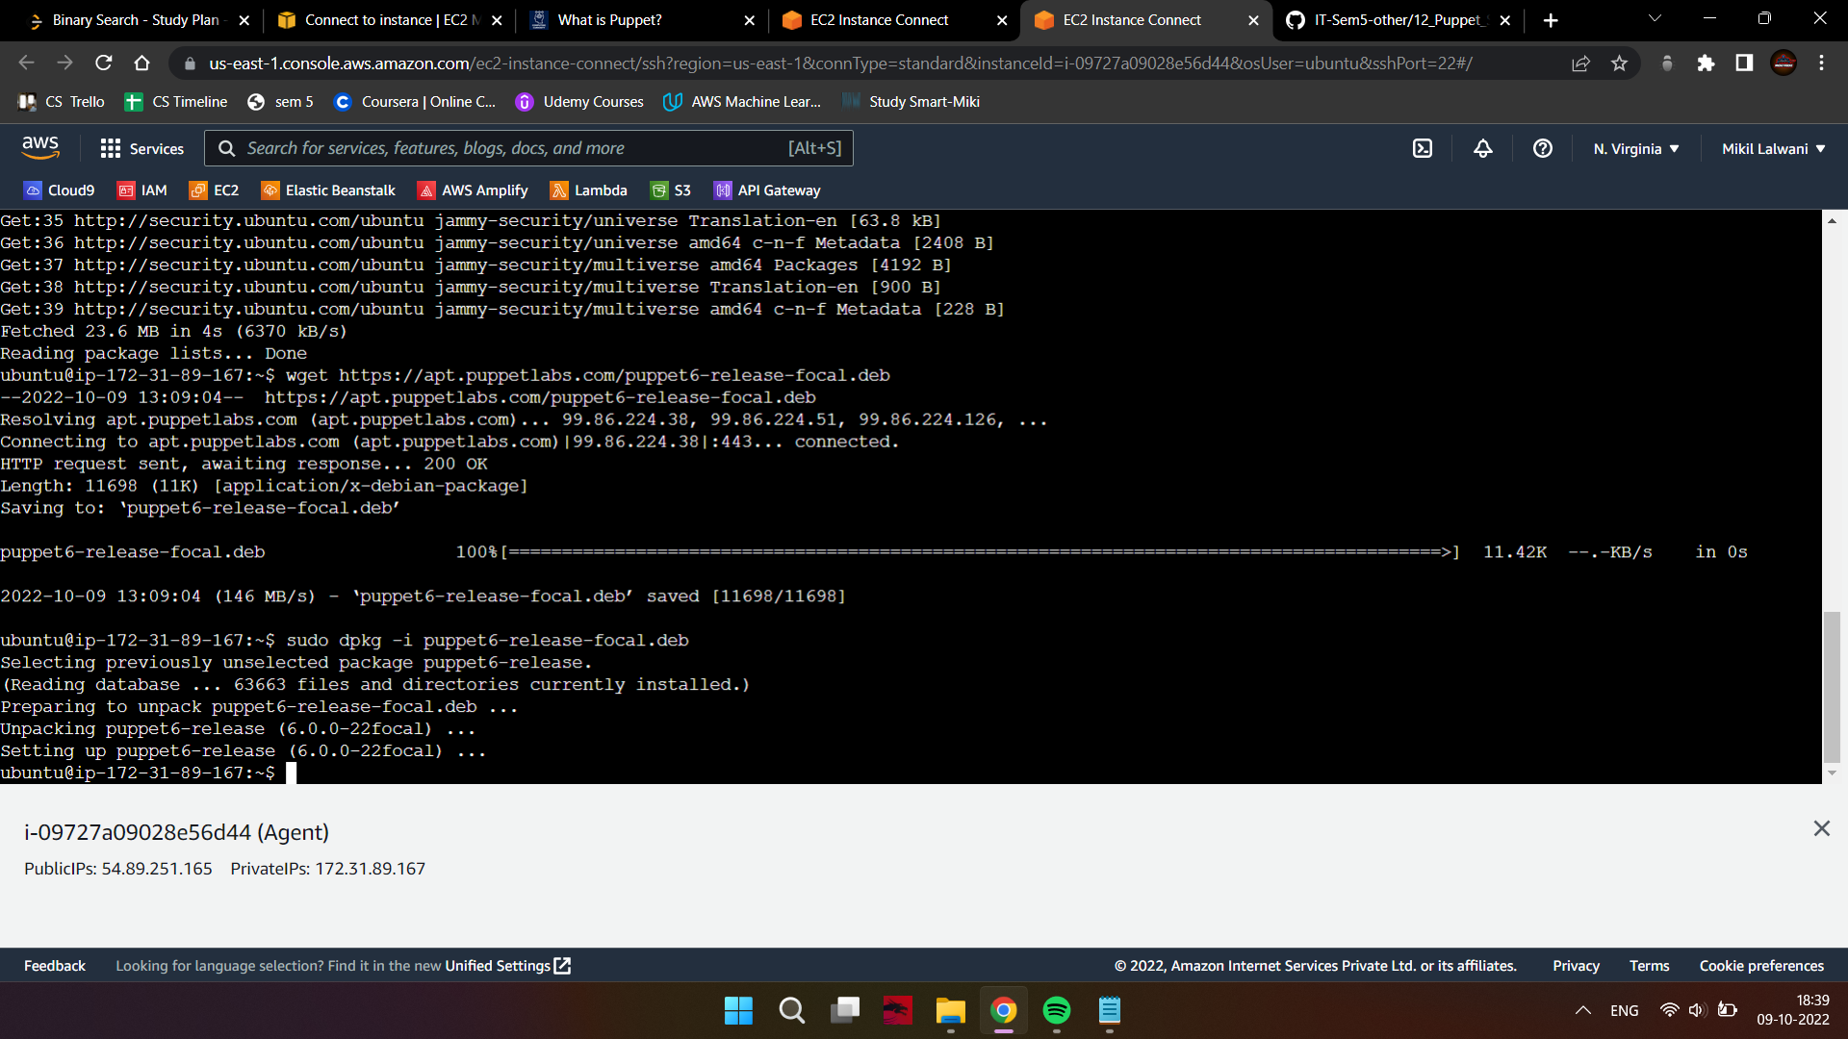

1. Update the package repository again.

sudo apt-get update -y

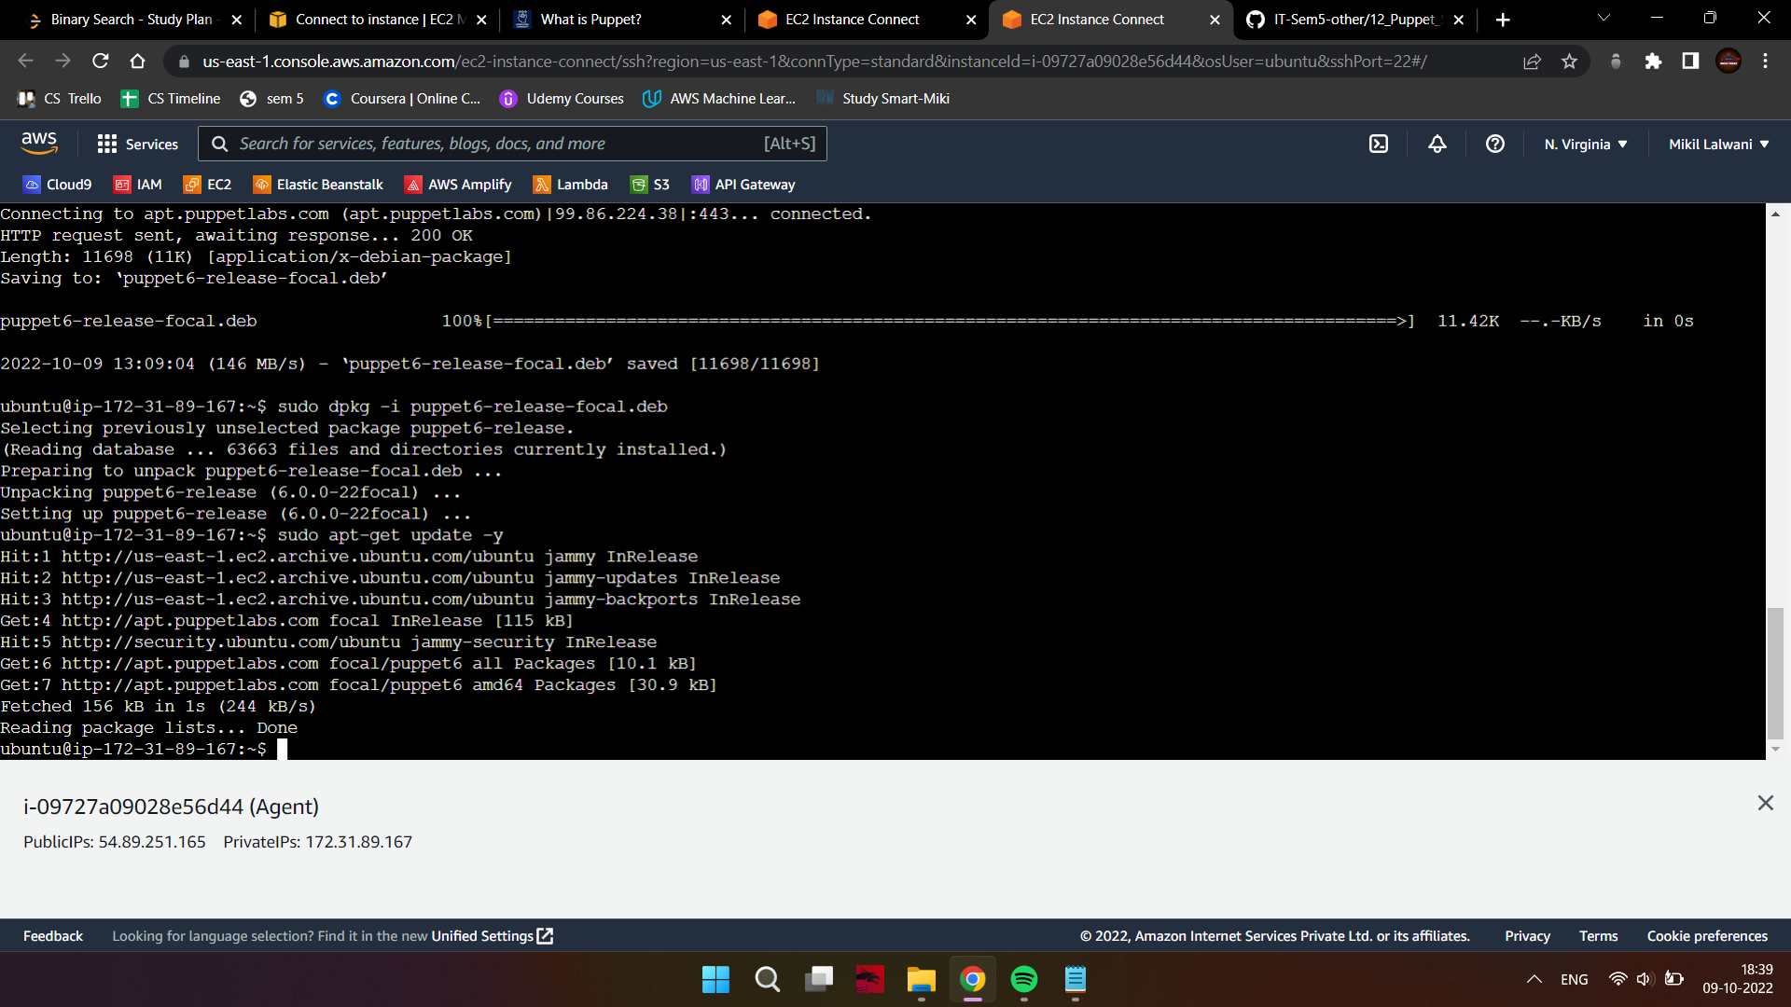

1. Install the agent using -

sudo apt-get install puppet-agent -y

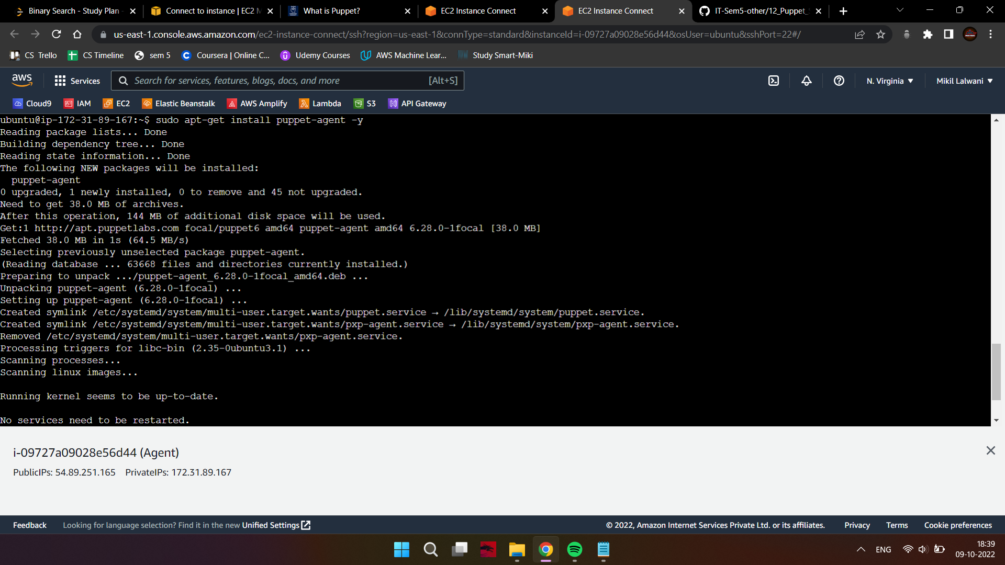

1. Start the puppet service and enable it -

sudo systemctl start puppet

sudo systemctl enable puppet

sudo systemctl status puppet

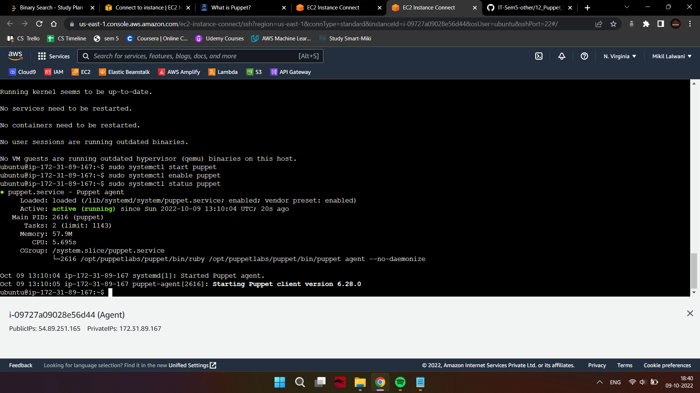

Now that our server and puppet agent both are running, we can proceed to sign the Agent Certificate.

Perform these commands only on the master machine.

1. On the master node, list requested certificates

sudo /opt/puppetlabs/bin/puppetserver ca list

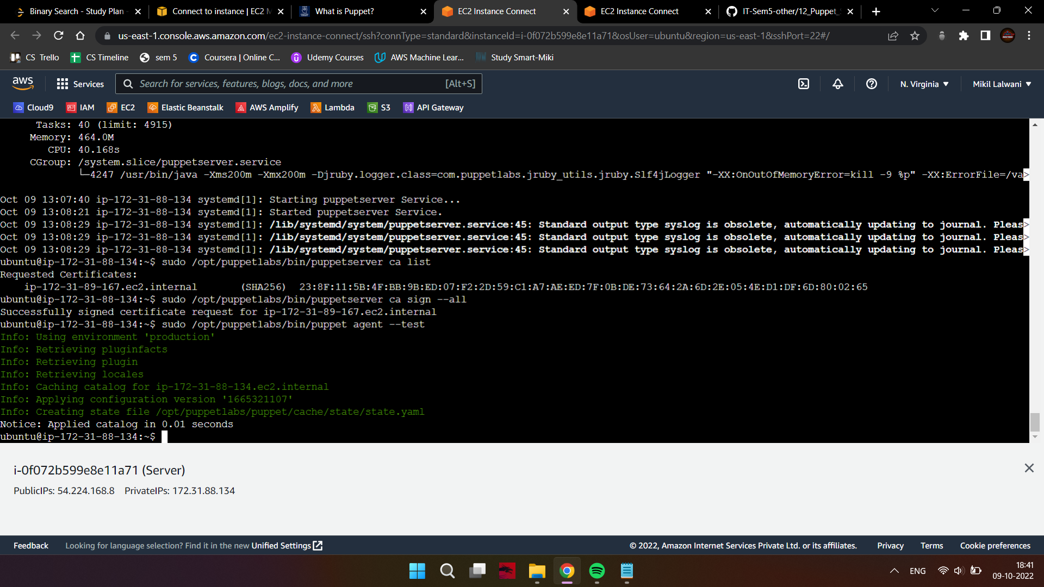

1. Once you spot the requested certificate from the client-side, you can sign it using -

sudo /opt/puppetlabs/bin/puppetserver ca sign --all



1. To test the connection, you can use the following command

sudo /opt/puppetlabs/bin/puppet agent --test



If all went good, you’ll get the notice of applying catalog, which means that puppet was configured properly on both machines.

**Conclusion:**

Thus, we studied puppet, installed it on our machines and set up a master-worker cluster on it.